Human Impact: Negative and Positive! Name________________________
Ch 26.1-3

Objective 6b: evaluate the human impact on greenhouse gases.
Objective 8: Compare and contrast the pros and cons of renewable and nonrenewable energy sources.
Objective 9: Develop a plan for both individuals and communities to conserve energy resources.

Part A: Carbon Footprint

- What is a carbon footprint (ecological footprint)?
Carbon Footprint Resource
the amount of CO₂ and other carbon compounds that are emitted due to the consumption of fossil fuels by a particular person, group, or event
- Complete the carbon footprint calculator. Insert a screenshot of your results. http://www.footprintcalculator.org/
Sjuts was 3.3 Earths
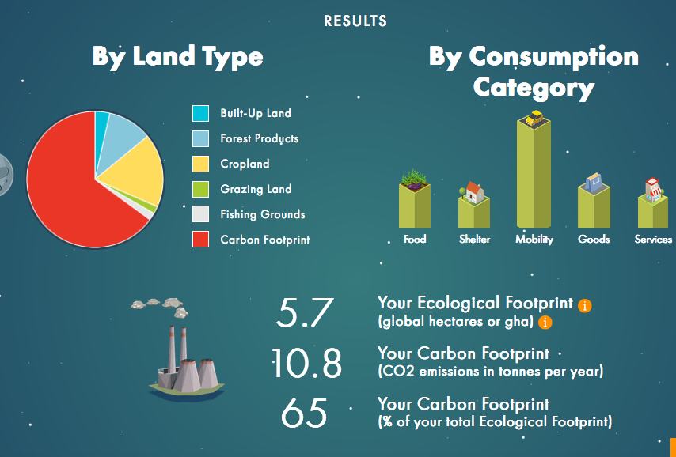
- What are some questions they asked? Why do you think they were on the assessment? Give 3 examples.

- How often do you eat beef, poultry, fish, pork, dairy?
- How much of your diet is fresh, unpackaged foods? How much is locally grown or produced?
- Home details? (style, composition, energy for home, trash produce, recycling)
- Water usage (brushing teeth, showers, etc.)
- How far do you travel in a car/week? Carpool? Fuel efficiency of car?

Part B: Be the change!

- List at least 3 changes you can make to reduce your carbon footprint.
- Garden or buy local (veggies, herbs)
- Carpool, plan errands strategically, Public Transportation, Bike, Walk
- Meatless Monday, Cell-based meat?, Blended burgers
- Turn off lights when leaving a room, E efficient windows, heating/cooling, appliances
- Recycle, compost

2. List at least 3 changes your community can make to reduce its footprint?

- Recycling mandates (cardboard ban in Lincoln), compost
- Carbon Sequestration
- Community gardens
3. What is carbon sequestration and why are universities studying it?
UNL CSP
Carbon Sequestration Resource

Carbon sequestration: natural and deliberate processes by which CO₂ is either removed from the atmosphere or diverted from emission sources and stored in the ocean, terrestrial environments (vegetation, soils, and sediments), and geologic formations.

•Ocean Sequestration: oceans are a primary long-term sink for human-caused CO₂ emissions
(global net uptake ~ 2 gigatons of carbon annually)
•Occurs naturally and affects the acidity of oceans
•Terrestrial Sequestration: forest and soil conservation practices that enhance the storage of carbon or reduce CO₂ emissions:
•EX: restoring and establishing new forests, wetlands, and grasslands (enhancing storage), reduce agricultural tillage and suppressing wildfires
•Geologic Sequestration: captures CO₂ from the exhaust of fossil fuel power plants and other major sources
•EX: captured CO₂ is piped 1 to 4 km below the land surface and injected into porous rock formations, currently only stores small amounts of carbon per year, plans to increase

4. Compare and contrast the pros and cons of renewable and nonrenewable resources. Give specific examples: fossil fuels, nuclear, wind, hydro, solar, geothermal, biomass. Alternative Energy Resource
Fossil Fuel Power Plant Video
Fossil Fuels
- Nonrenewable
- Benefits: a lot of coal is available in the U.S, transportation for f.f is cheap and easy, and f.f can power anything from cars to houses
- Limitations: Emits carbon dioxide (greenhouse gases), high levels of pollution, and main human-made contributor to global warming
Wind Generator Video
Wind:
- Renewable
- Benefits: Pollutants are less abundant, wind turbines don’t produce greenhouse gases, and you can collect wind just doing everyday things
- Limitations: good wind sites are usually in remote areas, isn’t a cheap and effective way to store electricity, and the places that get the most wind are the least populated areas
Pumped Storage Hydroelectric System Video
Hydro:
- Renewable
- Benefits: domestic source(every state can use it), clean fuel source(won’t produce greenhouse gases), and it is the cheapest way to produce energy.
Limitations: limited reservoirs, drought, and environmental conservation
Solar Panel Video
Solar:
- Renewable (Google sunroof project)
- Benefits: Sunlight contains a lot of energy, can help lower carbon dioxide emissions, and solar energy can be stored after the sun sets
- Limitations: Can’t use it when it’s dark or cloudy outside, solar panels can only convert about 20% of the sun rays into energy, and storing the energy raises the cost
Nuclear Power Plant Video
Nuclear
- Nonrenewable
- Benefits: Provides 20% of electricity generation in the U.S, lowers the amount of greenhouse gas emission, and the cost of nuclear fuel is 20% of the electricity generated
- Limitations: Once nuclear energy is gone, it’s gone for good, if there’s an accident radioactive material could be released into the environment, and nuclear waste remains hazardous and radioactive for thousands of years
Biomass:
- Renewable
- Benefits: can greatly decrease greenhouse gas emissions, supports U.S. agricultural and forest-product industries, and can reduce dependence on foreign oil
- Limitations: Agricultural waste will not be available if the basic crop is no longer grown, additional work is needed in area for things such as harvesting methods, and land for energy crops may be in demand for other purposes (farming, housing, resort, etc…)
Geothermal:
- Renewable
- Benefits: It would lower greenhouse gas emissions, always available for us to use, and it’s clean energy; doesn’t burn fossil fuels
- Limitations: Not a widespread source of energy → limits equipment, workers, etc, most geothermal generation needs a heat source 3 kilometers from the surface, and can release harmful/poisonous gases; geothermal power plants have to be able to contain these gases

