HPS – Stargazing Vocab Name _____________________________
Objective 2 Key Terms
Resources:
http://www.skyandtelescope.com/astronomy-resources/what-are-celestial-coordinates/
http://astro.unl.edu/classaction/animations/coordsmotion/radecdemo.html
http://astro.unl.edu/classaction/animations/coordsmotion/altazimuth.html
http://astro.unl.edu/classaction/animations/coordsmotion/celhorcomp.html

Directions: For each of the following terms, write the definition and sketch an image.

Declination: angular distance of a point north or south of the celestial equator (like latitude only in the sky) - Directly out from the Earth's equator, 0° latitude, is the celestial equator, 0° declination. If you stand on the Earth's equator, the celestial equator passes overhead. Stand on the North Pole, latitude 90° N, and overhead will be the north celestial pole, declination +90°.
Right ascension: like longitude only in the sky - Instead of counting in degrees, as with longitude around the Earth, right ascension is usually counted in hours, from 0 to 24 around the sky. This is just a different way of putting dividing marks on a circle. One hour in this scheme is 1/24 of a circle, or 15°.
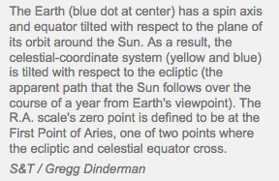
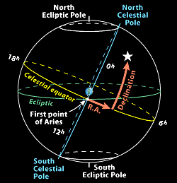

Ecliptic: a great circle on the celestial sphere representing the sun's apparent path during the year

Zenith: the point in the sky or celestial sphere directly above an observer
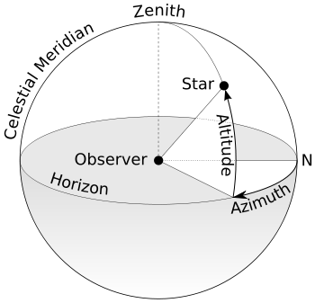

Altitude: distance an object appears to be above the horizon. The angle is measured up from the closest point on the horizon. If you stretch out your arm and make a fist, then your fist covers about 10 degrees on your field of vision,
Finger = ~1*
Finger tip to first knuckle = ~3*
Middle knuckle = ~4*
Third knuckle = ~6*
Fist = ~10*
Hang loose = ~25*

- Azimuth: angular distance along the horizon to the location of the object. It starts due North and increases clockwise to 90º East, then 180º South and then 270º West and finally back to 0º North.

North Star: Polaris, or the North Star, sits almost directly above the North Pole. Stars that sit directly above the Earth’s North or South Pole are called Pole Stars.

Southern Cross: used to find South, similar to Polaris (North Star)

Constellations: a group of stars forming a recognizable pattern that is traditionally named after its apparent form or identified with a mythological figure. Modern astronomers divide the sky into eighty-eight constellations with defined boundaries

