HPS: The 4 Spheres and their Interactions Name: ____KEY_______________________
Objective 2 (pg 7-9 Geoscience Textbook)
The spectacular eruption of a volcano destroying the magnificent scenery of a tropical forest and the destruction caused by a hurricane are all part of Earth’s spheres interacting with one another. The HYDROPSHERE is composed of the liquid that is continually on the move from the oceans to the atmosphere, precipitating back to the land, and running back to the ocean. The ATMOSPHERE is composed of all the gases that surround our earth. The atmosphere is a thin blanket of air that provides us with the air we breathe but also protects us from the sun’s intense heat and dangerous radiation. The GEOSPHERE is composed of the solid earth. It is divided into three parts: the core, mantle, and crust. The BIOSPHERE includes all life on Earth.

1. List ways the spheres interact with each other.
A. GEOSPHERE & ATMOSPHERE
- _Dust storm, transfer of thermal E_________________________________

B. GEOSPHERE & BIOSPHERE
- _Plant growing in soil, bear hibernating in a cave_____________________

C. GEOSPHERE & HYDROSPHERE
- _Puddle, infiltration (water cycle)_________________________________

D. GEOSPHERE & GEOSPHERE
- _Plate tectonics, earthquake_____________________________________
E. BIOSPHERE & BIOSPHERE
- _Reproduction, predator/prey relationship___________________________

F. BIOSPHERE & ATMOSPHERE
- _Bird flying in air, animal breathing in air (respiration), plant taking in carbon dioxide (photosynthesis)

G. BIOSPHERE & HYDROSPHERE
- _Cow drinking water, fish living in the lake__________________________
H. ATMOSPHERE & ATMOSPHERE
- _Front (boundary between two air masses), convection in atmosphere__________________________________________________
I. ATMOSPHERE & HYDROSPHERE
- _Precipitation (rain, snow falling), condensation (rain forming), hurricane__
J. HYDROSPHERE & HYDROSPHERE
- _Transfer of thermal E in ocean, tropical storm_______________________

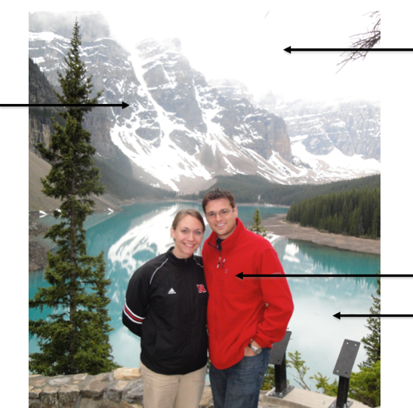
2. Create or find a picture containing the 4 different spheres. Label the spheres, and write a brief narrative describing the interactions. You may use the interactions you described above to help you.
Geosphere
Atmosphere
Narrative: My husband and I vacationed to Canada years ago. This photo was taken in Banff National Park showcasing beautiful, glacier-fed Lake Louise (hydrosphere) with the Canadian Rockies (geosphere) in the background. The air (atmosphere) that filled our (biosphere) lungs was cool and crisp this June day. The town of Banff in Alberta, Canada still remains one of the most beautiful places I have ever visited.
Hydrosphere
Biosphere

