HPS – Solar System Organization 2019 Name _____________________________
Objective 3
Solar System to Scale Clip
- Planet Characteristic Chart
 | Size  Large or small | Density  High or low | Atm  Thick or thin | Main Comp  Rock/metals or gases | Grav  High or low | Orbital speed  Slow or fast | Orbital period  Shorter or longer
Mercury
Venus
Earth
Mars
Jupiter
Saturn
Uranus
Neptune

- Solar System – Football Field: LABEL! Add the Kuiper Belt and Oort Cloud
https://www.nasa.gov/audience/foreducators/5-8/features/F_Solar_System_Scale.html

C. Solar System Formation | Notes and Sketches - Ch 29.4  http://www.windows2universe.org/our_solar_system/formation.html
1. Nebula Collapses
2. Nebula Spins
3. Sun Forms
4. Planetesimals Form
5. Planets Form

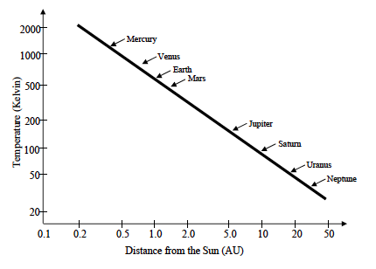
D. Temperature and Formation of Our Solar System
Introduction:
During for formation of our Sun and the surrounding planets, there is a definite line at about 3 AU from our Sun (an AU – Astronomical Unit – is the average distance between Earth and Sun), when it was cold enough for hydrogen and helium gas to freeze into ice pellets. Closer to the Sun than this, hydrogen and helium stays in gaseous form whereas farther than this, hydrogen and helium freeze. This impacts what our planets are predominantly composed of.
Instructions:
Consider the information provided in the graph and table below. The graph shows the temperature (expressed in Kelvin) at different distances from the Sun (expressed in astronomical units or AU) in the solar system during the time when the planets were originally forming.

Does this make sense? Is this normal compared to the rest of the solar systems we have found??

Read the article found at the link below, and be prepared to discuss.
http://www.npr.org/blogs/krulwich/2013/05/06/181613582/our-very-normal-solar-system-isn-t-normal-anymore
Is our solar system the odd one out? Explain.

E. Extrasolar Planets - https://www.space.com/17738-exoplanets.html
INQUIRING MINDS WANT TO KNOW!!

