HPS Electromagnetic Spectrum 2020 Name______________________

Objectives:

Background Information: Radio waves, microwaves, visible light, and x-rays are familiar kinds of electromagnetic waves. All of these waves have characteristic wavelengths and frequencies. Wavelength is measured in meters. It describes the length of one complete oscillation. Frequency describes the number of complete oscillations per second. It is measured in hertz, which is another way of saying “cycles per second.” The higher the wave’s frequency, the more energy it carries.
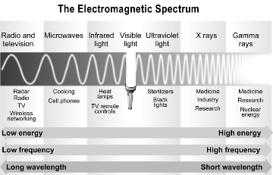

Frequency, wavelength, and speed
In a vacuum, all electromagnetic waves travel at the same speed: 3.0 × 108 m/sec. This quantity is often called “the speed of light” but it really refers to the speed of all electromagnetic waves, not just visible light. It is such an important quantity in physics that it has its own symbol, c.
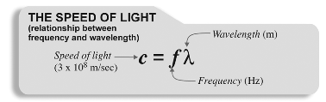
The speed of light is related to frequency f and wavelength λ by the formula.
The different colors of light
that we see correspond to
different frequencies. The
frequency of red light is lower
than the frequency of blue
light. Because the speed of both kinds of light is the same, a lower frequency wave has a longer wavelength. A higher frequency wave has a shorter wavelength. Therefore, red light’s wavelength is longer than blue light’s.
When we know the frequency of light, the wavelength is given by: λ = c/ f
When we know the wavelength of light, the frequency is given by: f = c/ λ

Answer the following problems and show your work.
- Yellow light has a longer wavelength than green light. Which color of light has the higher frequency?
- Green light has a lower frequency than blue light. Which color of light has a longer wavelength?
- Calculate the wavelength of violet light with a frequency of 750 × 1012 Hz.
- Calculate the frequency of yellow light with a wavelength of 580 × 10–9 m.
- The waves used by a microwave oven to cook food have a frequency of 2.45 gigahertz (2.45 × 109 Hz). Calculate the wavelength of this type of wave.
- A radio station has a frequency of 90.9 megahertz (9.09 × 107 Hz). What is the wavelength of the radio waves the station emits from its radio tower?
- An x-ray has a wavelength of 5 nanometers (5.0 × 10-9 m). What is the frequency of x-rays?
- The ultraviolet rays that cause sunburn are called UV-B rays. They have a wavelength of approximately 300 nanometers (3.0 × 10-7 m). What is the frequency of a UV-B ray?
- Infrared waves from the sun are what make our skin feel warm on a sunny day. If an infrared wave has a frequency of 3.0 × 1012 Hz, what is its wavelength?
- Electromagnetic waves with the highest amount of energy are called gamma rays. Gamma rays have wavelengths of less than 10-trillionths of a meter (1.0 × 10-11 m).
  - Determine the frequency that corresponds with this wavelength.
  - Is this the minimum or maximum frequency of a gamma ray?
- Use the information from this sheet to order the following types of waves from lowest to highest frequency: visible light, gamma rays, x-rays, infrared waves, ultraviolet rays, microwaves, and radio waves.
- Use the information from this sheet to order the following types of waves from shortest to longest wavelength: visible light, gamma rays, x-rays, infrared waves, ultraviolet rays, microwaves, and radio waves.

