HPS Waves Class Notes 2020 Name _________________

Objectives: Outline the properties of waves (i.e. velocity, wavelength, frequency, period, and amplitude) and describe their relationship (Obj 1); Describe the composition and production of electromagnetic waves (Obj 2); Compare and contrast regions of the electromagnetic spectrum based on frequency, wavelength, and energy (Obj 4).

Wave: repeating disturbance or movement (vibration) that transfers energy through matter and space.
- Mechanical Wave: requires a medium (material through which a wave travels)
EX: water, sound, slinky, rope, table cloth
  - Transverse Wave: matter moves perpendicular to the energy/direction of the wave
EX: light
    - Crest: highest point on the wave
    - Trough: lowest point on the wave
    - Wavelength: distance from one spot on a wave to the same spot on the next wave
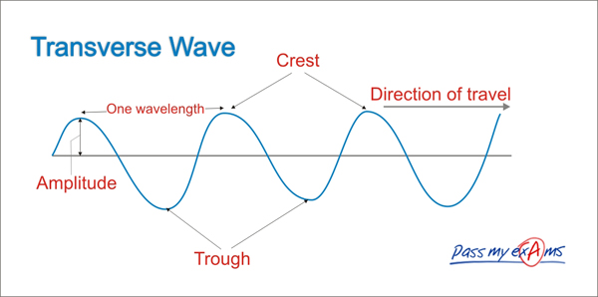
    - Amplitude: height of wave from resting position to crest or trough (measure of the E in a wave)
  - Compressional Wave: matter moves parallel to the energy/direction of the wave
EX: sound
    - Compression: medium spaced close together
    - Rarefaction: medium spread out
    - Wavelength: distance from one spot on a wave to the same spot on the next wave (same as transverse wave)
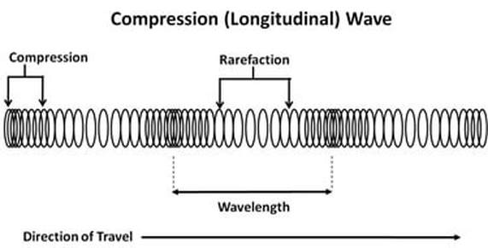
    - Amplitude: related to how squished/spread out the compressions/rarefactions are
- Electromagnetic Wave: transverse wave consisting of changing electric fields and changing magnetic fields (may or may not travel through a medium) and traveling at c (3.00x10⁸ m/s)
EX: light (all parts of EM spectrum)
  - EM Wave Composition
    - Electric Field - a region in space that exerts electric forces on charged particles
→ produced by electric charges or changing magnetic fields
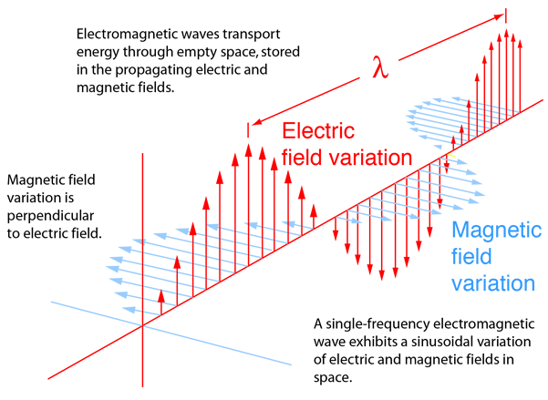
    - Magnetic Field - a region of space that exerts magnetic forces
→ produced by magnets, changing electric fields, or moving charges
  - EM Wave Production
    - EM waves are produced by constantly changing fields caused when an electric charge vibrates or accelerates
    - Fields are perpendicular to each other
    - Changing electric fields produce changing magnetic fields AND changing magnetic fields produce changing electric fields. (they regenerate each other!)
  - EM Spectrum
    - Full range of frequencies of EM radiation
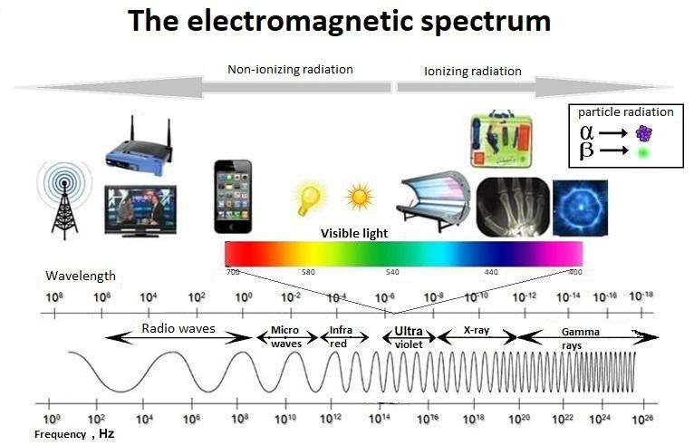
    - Long wavelength, low frequency, low E Radio waves
    - Short wavelength, high frequency, high E Gamma rays
- Calculations
  - Frequency (f) = the number of cycles per second
# cycles/second, f = 1/T, measured in Hz, 1/s, s⁻¹
  - Period (T) = time it takes for 1 cycle to pass through a point
seconds/# cycles, T = 1/f, measured in s
  - Wavelength (λ) = 1 point on a wave to the same point on the next wave
λ = v/ f, measured in m
  - Wave speed (v) = f x λ measured in m/s
  - Sample 1: A drum is struck, producing a wave with a wavelength of 120cm and a speed of 2.24x10⁴ m/s. What is the frequency? Period?
  - Sample 2: A certain FM radio station broadcasts EM waves at a frequency of 8.89x10⁷ Hz. What is the wavelength? c = f x λ where c = (3.00x10⁸ m/s)

