NEWTON’S SECOND LAW Name_______________________ Pd ____

- An object weighs 98 N on Earth. How much does it weigh on Planet X where the acceleration due to gravity is 6 m/s²?

- If the force of friction acting on a sliding crate is 100 N, how much force must be applied to maintain a constant velocity?

- What will be the net force acting on the crate?

- What will be the acceleration?

- How much does an astronaut weigh out in space, far from any planets?

- If the forces exerted on a 2-kg object are 50 N east and 30 N west, what is object’s acceleration?

- Suppose a cart is being pushed by a certain net force. If the net force is doubled, by how much does the acceleration change?

- Suppose a cart is being moved by a certain net force. If a box is dumped into the cart, so its mass is doubled, by how much does the acceleration change?

- If a loaded truck can accelerate at 4 m/s² and loses its load so it is only half as massive, what acceleration can it attain for the same driving force?

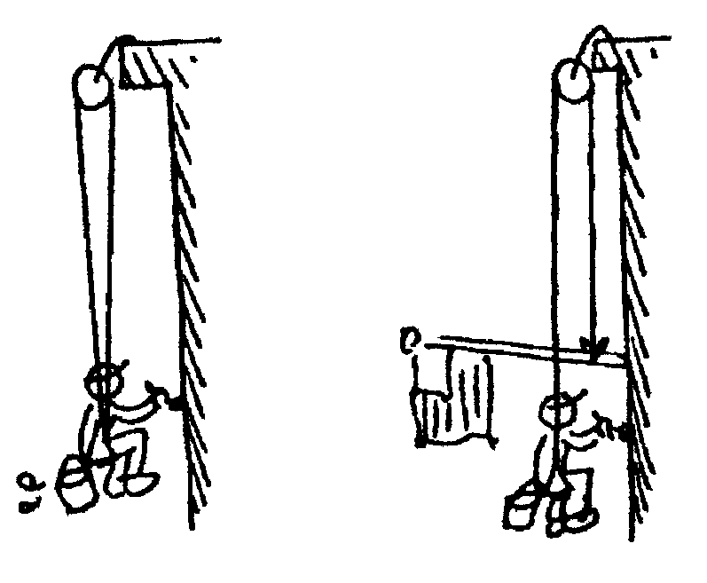
- Harry the painter swings year after year from his boson’s chair. His weight is 500 N and rope unknown to him, has a breaking point of 300 N. Why doesn't the rope break when he is supported as shown in the first figure to the right?

- One day Harry is painting near a flagpole, and for a change, he ties the free end of the rope to the flagpole instead of to his chair. What happens to Harry?

- The force of gravity is twice as great on a 2-kg rock as on a 1-kg rock. Why then does the 2-kg rock not fall with twice the acceleration?

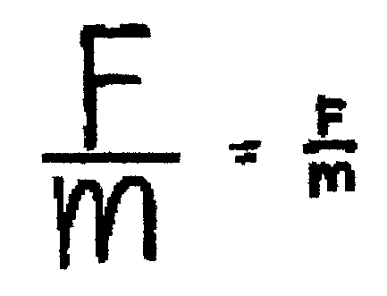
- What is the net force acting on a 10 kg freely falling object?

- What is the net force when it encounters 15 N of air resistance?

- How much air resistance does it experience when it falls at terminal velocity?

Newton’s 2nd Law Practice

Name______________________________ Period______________

Part I: Problem Solving. Solve the following problems. Show work and proper units.
(2 points each)

1. How much force is needed to accelerate a 1000-kg car at a rate of 3 m/s²?

2. If a 70-kg swimmer pushes off a pool wall with a force of 250 N, at what rate will the swimmer accelerate from the wall?

3. A weightlifter raises a 200-kg barbell with an acceleration of 3 m/s². How much force does the weightlifter use to raise the barbell?

4. A dancer lifts his partner above his head with an acceleration of 2.5 m/s². The dancer exerts a force of 200 N. What is the mass of the partner?

5. What does Newton’s second law of motion state?

What two factors affect the rate of acceleration of an object?

6. ______________________________________________________________

7. ______________________________________________________________

