Ch 12-1: What is a force? Name ______________________________
Basic Physical Science Notes 2018

Key Terms:
- Force: _________________________________________________________________
________________________________________________________________________
EX:

- Force is measured in ______________. (Hint: you may have to google this.)

- Balanced forces: ___________________________________________________________
_________________________________________________________________________
EX:

- Unbalanced forces: ___________________________________________________________
___________________________________________________________________________
EX:

- Net Force is when you add up all the _____________ together.

 | Balanced Forces | Unbalanced Forces
Net Force is: = to zero OR not = to zero?
Causes an object to accelerate? Y or N
(accelerate means to change motion)
Forces are equal and opposite? Y or N

Short Answer:
- Is a force scalar or vector? Does the direction of the force matter?
- How do unbalanced forces change the motion of an object? (2 ways)
- To describe a force, you must know the size and _________________ of the force.
- How is weight a force? What direction is it?
- For each picture, circle balanced or unbalanced and tell the Net Force.
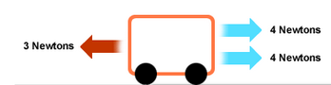
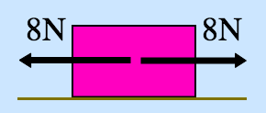

BALANCED UNBALANCED
Net Force = _________ Newtons
BALANCED UNBALANCED
Net Force = _________ Newtons

