Factors Influencing Climate Name _________________________________ Per _______
HPS 2019 - Chapter 14.1 & 14.3

Objective 3: Describe natural causes/influence on global climate.

- List and describe factors that influence climate. (page 361-363 GS book)

a.

b.

c.
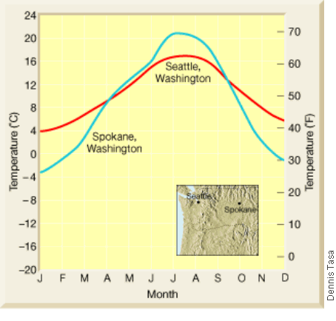
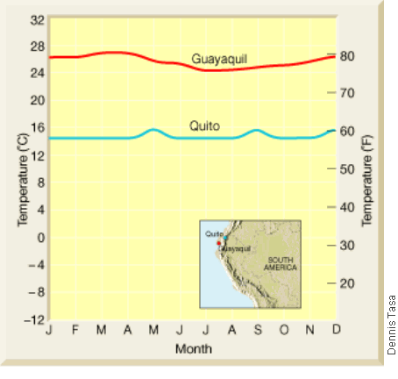
2. Under each map/graph, explain why the two cities have differing climates.
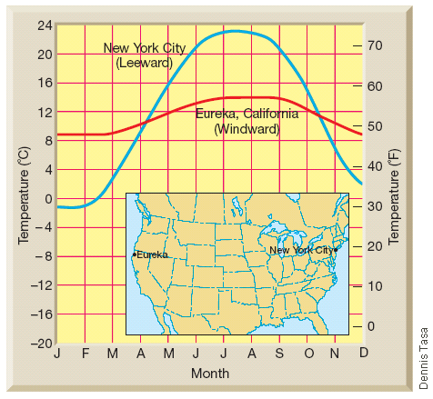

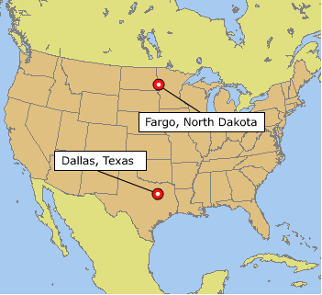
3. Predict the climate differences for these two cities. Explain your prediction.

Briefly explain how the following influence global climate.

1. Seasons due to Earth’s tilt on its axis
2. Volcanism
3. El Nino
4. Solar activity (sunspots)
5. Milankovitch Cycles
Part 1: Earth’s wobble (every 26,000 yrs)
Part 2: Earth’s orbit (changes every 100,000 yrs)
Part 3: Earth’s tilt (every 41,000 yrs)
6. Atmospheric composition

Greenhouse Effect:

