Factors Influencing Climate Name _________________________________ Per _______
HPS 2021 - Chapter 14.1, 14.3, 14.4

Objective 5: Describe natural causes/influence on global climate.

- List and describe factors that influence climate. (page 361-363 GS book)

a.

b.

c.
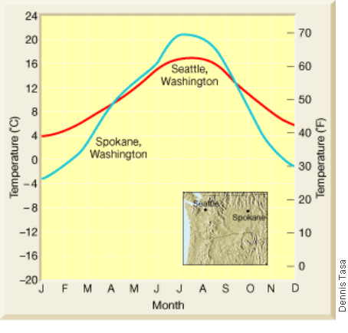
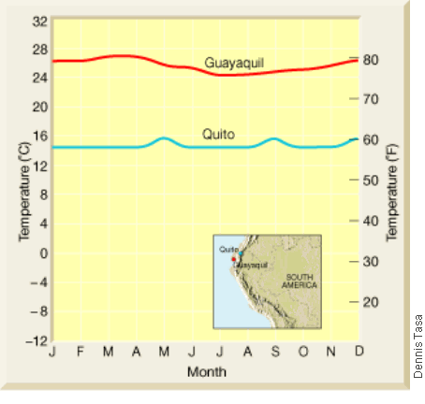
2. Under each map/graph, explain why the two cities have differing climates.
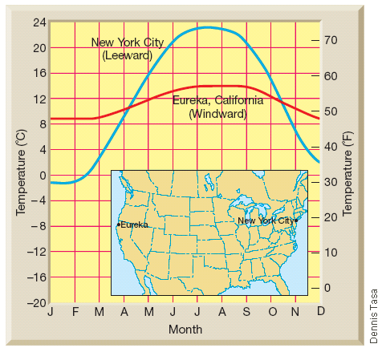
*You may research these cities.

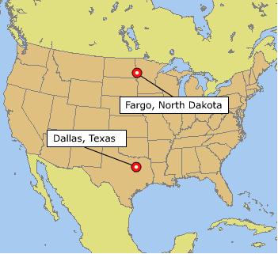
3. Predict the climate differences for these two cities. Explain your prediction.

Briefly explain how the following influence global climate change. (pg 369-377)

1. Ice Ages

2. Seasons due to Earth’s tilt on its axis
3. El Nino

4. Solar Activity

5. Milankovitch Cycles
Part 1: Earth’s orbit (changes every 100,000 yrs)
Part 2: Earth’s tilt (every 41,000 yrs)
Part 3: Earth’s wobble (every 26,000 yrs)

6. Volcanism

7. Atmospheric composition

Greenhouse Effect:

