Greenhouse Effect Exploration Name _____________________ Per ______
Honors Physical Science 2019

Click the links and answer the questions below.
https://www.windows2universe.org/earth/Atmosphere/earth_atmosph_radiation_budget.html

- Which EM wavelengths reach the ground?
- Explain how Earth’s atmosphere is much like the glass in a greenhouse.
- How does the temperature of our “airless Earth” differ from our actual Earth?
https://climate.nasa.gov/causes/

- Describe the following Greenhouse Gases:
  - Water vapor
  - Carbon dioxide
  - Methane
  - Nitrous oxide
https://www.windows2universe.org/earth/climate/cli_greengas.html
- Describe what happens to the atoms when they absorb heat.

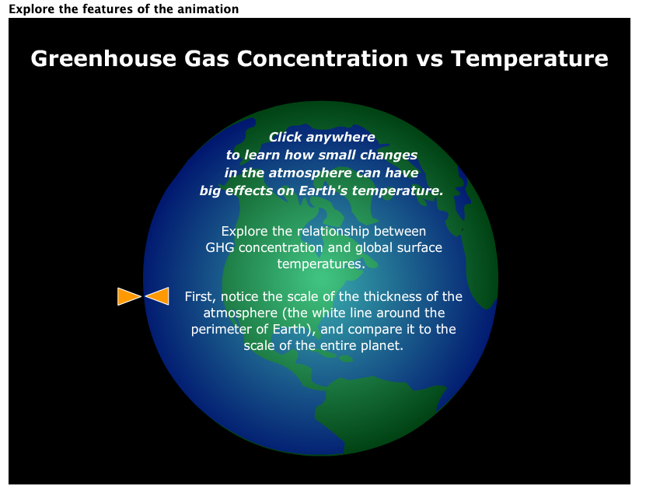
https://serc.carleton.edu/eslabs/weather/2c.html

- Scroll down until you see the animation (picture shown). Click on the Earth and answer the questions:
  - How does the temperature change with CO₂ levels? CH₄ levels? N₂O levels?
  - Which gas causes the biggest change in temperature?
  - Describe how the GHG levels have changed from 1850 to today. What affect has that had on global temperatures?
  - According to the simulation, what is predicted for 2100?
- Both instrumental and satellite data show that the years between 2000 to 2010 were the warmest decade of the past 150 years, and 2014 was warmest year on record since 1880. In fact, 9 of the 10 warmest years on record have occurred during the 21st century. (Source: NOAA State of the Climate 2014)
View the video “Piecing Together the Temperature Puzzle” (5 min, 48 sec) near the bottom of this webpage, and explain what could be causing the heating of the planet.

SUMMARIZE
- Using your own words (not the internet’s words), explain the Greenhouse Effect. Include a sketch to help.

- What is global warming (climate change) and how does it relate to the Greenhouse Effect?

- What are some possible consequences of global warming/climate change?

- What role do humans play in GHG concentrations in the atmosphere?

