HPS Ch 16.1-2 Temperature, Heat, Thermal Energy 2020 Name ____________________

OBJECTIVES: Compare and contrast the relationships between temperature, thermal energy, and heat. (Obj 3) Describe how thermal energy is transferred by conduction, convection and radiation. (Obj 4
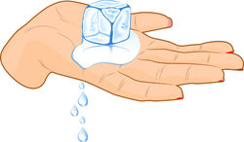
- Define heat. Describe the heat flow based on the picture (hand holding ice).

- We used to think of temperature as how hot or cold something is, but now we are focusing on temperature as related to something else. Explain and include the acronym T.A.K.E.
- Describe the three temperature scales.
- What is thermal energy? How is this different than mechanical energy?
- Give an example that illustrates how thermal energy depends on mass.
- Give an example that illustrates how thermal energy depends on temperature.
- Draw an example of conduction and explain on a molecular level.
- Why is conduction in gases slower than in liquids and solids?
- Convection, which occurs in fluids, is very important! Sketch and describe three examples of convection currents that occur in natural cycles.
a.

b.

c.
- Describe an example of radiation. Why is radiation unique?

