Honors Academy Mission Statement & Learner Profile

The International Baccalaureate aims to develop inquiring, knowledgeable and caring young people who
help to create a better and more peaceful world through intercultural understanding and respect.
To this end the organization works with schools, governments and international organizations to develop challenging programmes of international education and rigorous assessment.
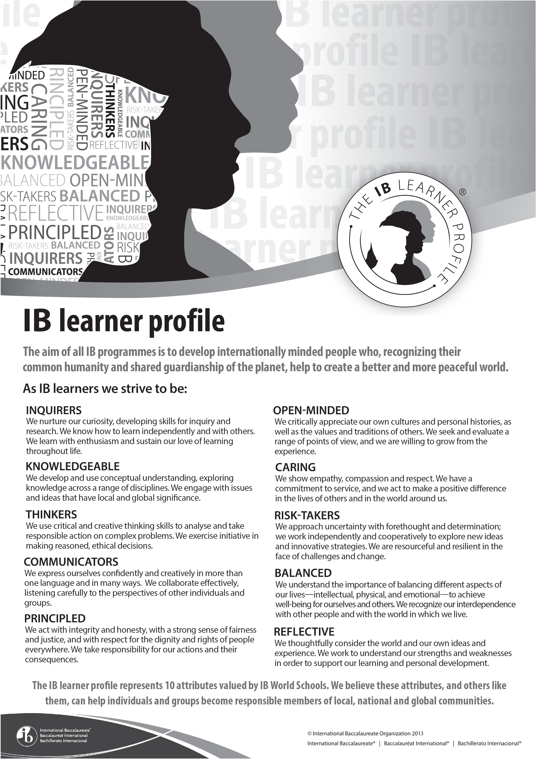
These programmes encourage students across the world to become active, compassionate and lifelong
learners who understand that other people, with their differences, can also be right.

