Rates of Reaction Lab 2020 Name(s): _________________________________

Pre-lab discussion

The rate of a chemical reaction is the time required for a given quantity of reactant(s) to be changed to product(s). Reaction rate usually is expressed in terms of moles per unit time. This rate is affected by several factors, including surface area, concentration of the reactants, temperature, and the presence of catalysts. In this experiment, you will study the effects of both temperature and concentration.
According to collision theory, a chemical reaction occurs only when particles collide with sufficient energy and correct orientation. Increasing the temperature raises the average kinetic energy of the particles. This results in more collisions and, more importantly, more effective collisions per unit time. This affects the rate of the reaction.
At constant temperature, increasing the concentration of one or more of the reactants increases the number of particles present and, hence, the number of collisions. This affects the rate of the reaction.
In this experiment, two solutions will be mixed and the completion of the reaction will be marked by a color change. One solution contains the iodate ion (IO₃⁻). The other contains the hydrogen sulfite ion (HSO₃⁻) and soluble starch. The entire reaction takes place in two stages. The ionic equations for these are:
1. IO₃⁻_{(aq)} + 3HSO₃⁻_{(aq)} --> I⁻_{(aq)} + 3SO₄²⁻_{(aq)} + 3H⁺_{(aq)}

2. 5I⁻_{(aq)} + 6H⁺_{(aq)} + IO₃⁻_{(aq)} --> 3I_{2(aq)} + 3H₂O_{(l)}

In the presence of starch molecules (not shown), molecular iodine (I₂) produces a characteristic blue/purple color. The rate of the entire reaction can be determined by timing the interval between the time the two solutions are mixed an the appearance of the blue color. By varying the concentrations of one of the reactants (at constant temperature) and then varying the temperature (with constant concentration), you can observe and record the effects of these two factors on reaction rate.

Purpose

Study the effect that changing the concentration of a reactant has on the rate of a chemical reaction. Study the effect that changing the temperature has on the rate of a chemical reaction. Formulate hypotheses about how reaction rates are affected by changes in temperature in a concentration of reactants.

Equipment & Materials

250 mL beaker (1) - Part B only 18x150-mm test tubes (2)
Stop watch 10 mL graduated cylinder (2)
safety goggles thermometer – Part B only
water ice cubes – Part B only
Solution A (with IO₃⁻ ion) Solution B (with HSO₃⁻ ion and soluble starch)

Procedure

Part A – Concentration (Diluting of A)
1. Using a clean, dry, 10-mL graduated cylinder, measure 5.0 mL of solution A and pour it into a test tube.
2. Using a second 10-mL graduated cylinder, measure 5.0 mL of solution B and pour it into a second test tube.
3. Prepare to time the reaction. While one lab partner pours solution A into solution B, the second partner should immediately start timing the reaction. Swirl the test tube rigorously to ensure thorough mixing. Then allow the mixture to stand. At the instant a color change occurs, the partner timing the reaction should note the elapsed time. Record this in the data table for trial 1. Rinse and dry the test tubes and graduated cylinders.
4. Measure 5.0 mL of solution B into one of the test tubes. Using a graduated cylinder, measure 4.0 mL of solution A into the other test tube. Dilute this solution by adding 1.0 mL of water. Follow the step 3 instructions for mixing the solutions and timing the reaction. Record the elapsed time in your data list for trial 2. Rinse and dry the test tubes and graduated cylinders.
5. Repeat step 4 four more times, using increasingly dilute samples of solution A. Use the following ratios of solution A to distilled water (in mL): 3 to 2; 2 to 3; 1 to 4. Rinse and dry the test tubes and graduated cylinders after each trial. Record elapsed times in the table for trial 3, trial 4, and trial 5.

Part B – Temperature
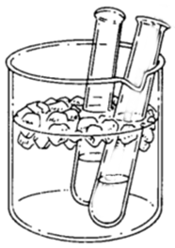
6. Measure 5.0 mL of solution A into one test tube and 5.0 mL of solution B into a second test tube.
7. Place the two test tubes in the ice-water bath and let them stand until the solutions are at the same temperature as the ice water (several minutes).
8. When the solutions are at the same temperature as the ice water, prepare to time the reaction. One lab partner should start timing the reaction the instant the second partner pours solution A into solution B. Quickly swirl the test tube rigorously and return the mixture to the ice-water bath. At the instant a color change occurs, note the time elapsed. Measure the temperature of the mixture. Record the temperature and elapsed time in your data table for trial 1. Discard the mixture as instructed. Rinse and dry the test tubes.
9. Repeat step 6.
10. Repeat steps 7 and 8 at room temperature (no water bath). Make sure to measure the temperature of the room. Record your observations in your data table for trial 2.
11. Repeat these procedures using warm baths at the following temperatures: ~40°C, ~60°C. Use a hot plate to prepare these bathes. (Exact temperatures don’t have to be reached – we want a temperature differential.) Rinse and dry the test tubes after each trial. Record your results in the data table for trials 3 and 4.

Observations and Data
Part A – Concentration (Diluting of A)

Trial | Solution B (mL) | Solution A (mL) | H₂O (mL) | Time (sec)
1 | 5.0 | 5.0 | 0
2 | 5.0 | 4.0 | 1.0
3 | 5.0 | 3.0 | 2.0
4 | 5.0 | 2.0 | 3.0
5 | 5.0 | 1.0 | 4.0

Part B - Temperature

Trial # | Temperature (°C) | Time (sec)
1 (Ice Bath)
2 (Room Temp)
3 (~40°C)
4 (~60°C)

Calculations
1. Plot your data from part A on the grid provided. Draw a line through the plotted points to produce a curve showing the effect of concentration of reactants on reaction rate.

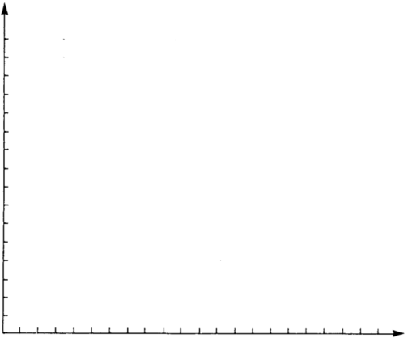
Reaction Time (sec)

mL of Solution A

2. Plot your data from part B on the grid provided. Draw a line through the plotted points to produce a curve showing the effect of temperature on reaction rate.
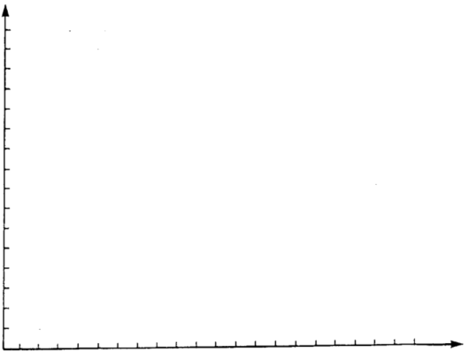

Reaction Time (sec)

Temp (°C)
Conclusions and questions

1. Based on your experimental data, make a general statement (hypothesis) about the effect of concentration of reactants on reaction rate.

2. Make a similar hypothesis about the effect of temperature on reaction rate.

3. What other factors affect the rate of a reaction?

4. How does "collision theory" relate to the rate of a chemical reaction?

