HPS Measurement Packet Questions 1 Name ______________________ Per _____

OBJECTIVE: compare and contrast random errors and systematic errors, giving examples and how to prevent if possible.

BACKGROUND INFO: Science aims to come to a common understanding of the universe. Scientists suspend judgement until they have a good reason to believe a claim to be true or false - evidence! Evidence comes from observation and experimentation. Evidence is used to:
- Develop theories: well-tested explanation of things or events based on observations & investigations (research). (can change)
- Generalize data to form laws: statements about what happens in nature and that seems to be true all the time. (tell what happens, but doesn’t always explain why or how)
- Propose hypotheses: explanatory statements (could be true or false) suggesting a relationship between 2 factors.

Types of Errors:

- Draw or insert a picture illustrating the difference between accuracy and precision.
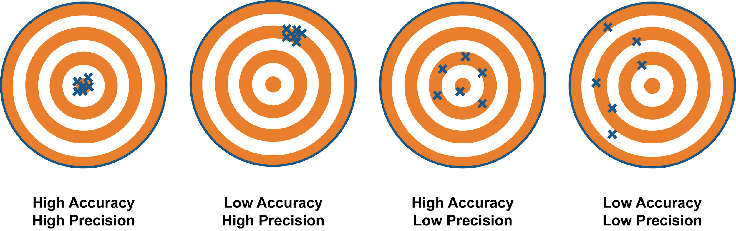
- According to the packet, are measurements ever exact? Explain.
No measure is ever exact due to errors in instrumentation and measuring skills.
- What are significant figures? Why are they important?
Significant figures are known digits in a measurement. They are important, because they reflect the precision of the measurement device.
- What determines the precision of a measurement?
The measurement device/tool used determines the precision of a measurement.
- Using a table, Venn Diagram, or other graphic organizer, compare and contrast random and systematic errors.
When writing the conclusion to your lab report you should evaluate your experiment and its results in terms of the various types of errors. You should consider the size of the systematic errors compared to the random errors.
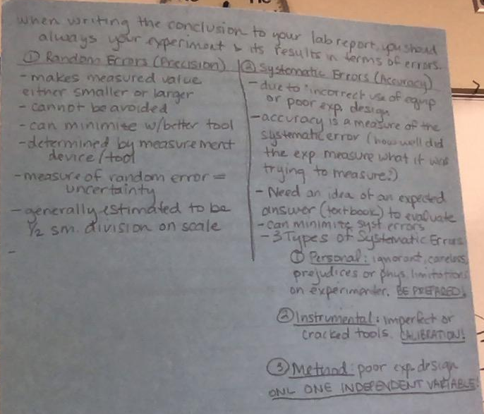
- Complete the table outlining the three types of systematic errors:

 | What the error could be | How to avoid the error
Personal Error | Rushing, being careless, unfamiliar with the procedure | Take your time, read the lab ahead of time, be prepared
Instrumental Error | Leaky syringe, uncalibrated tool | Be sure tools are working properly and are calibrated
Method Error | Multiple independent variables in the procedure | Control more variables so you only have 1 independent variable
- Actively read the rest of the packet, paying specific attention to proper measurement technique, finding the uncertainty, and significant figures.

