HPS Measurement Packet Questions 2 Name ______________________ Per _____

OBJECTIVE: measure length, volume, and mass with correct accuracy and precision using a variety of measuring devices. (Obj 2)

BACKGROUND INFO: No measure is exact due to errors in instrumentation and measuring skills. Therefore, all measurements have inherent uncertainty that must be recorded. When you report a number as a measurement, the number of digits and the number of decimal places tell you how exact the measurement is. That is precision.

- What is the degree of freedom? (The packet refers to it as the “estimate” on the last line of the first paragraph on page 1.)
- List and describe the three parts of a COMPLETE measurement along with an example of a measurement.
A.
1.
2.
B.
1.
2.
C.
1.
2.
EX:
- Write the letter of the measurement tool that could produce the following measurements. Assume all tools are in centimeters.
15.4 ± .5 cm _______ 15 ± 5 cm _______ 15.47 ± .05 cm _______
A. B. C.
- Which measurement/device is the most precise? Explain.
- Measure the length of the square. Report all parts of the measurement. _______________
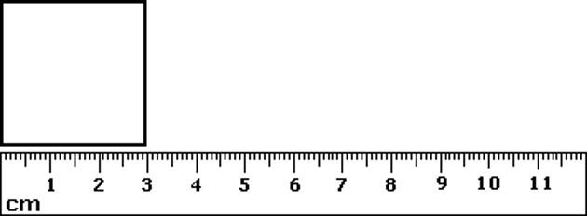

- Measure the mystery liquid. Report all parts of the measurement. ______________mL
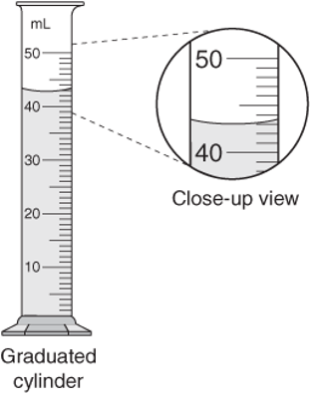

- Draw a measuring device that would give 7.3 ± .5 cm as a measurement.
- Why do we need a standardized system of measurement?
- Complete the table with the SI units and symbols.
Physical Quantity | SI Unit | Symbol
length
mass
volume
temperature
time

