HPS Measurement Packet Questions 2 Name ______________________ Per _____

OBJECTIVE: measure length, volume, and mass with correct accuracy and precision using a variety of measuring devices. (Obj 2)

BACKGROUND INFO: No measure is exact due to errors in instrumentation and measuring skills. Therefore, all measurements have inherent uncertainty that must be recorded. When you report a number as a measurement, the number of digits and the number of decimal places tell you how exact the measurement is. That is precision.

- What is the degree of freedom? (The packet refers to it as the “estimate” on the last line of the first paragraph on page 1.)
The last recorded digit in a measurement is your estimate or degree of freedom.
- List and describe the three parts of a COMPLETE measurement along with an example of a measurement.
A. Measurement
1. Write what know
2. Include the degree of freedom
B. Uncertainty (random error)
1. ½ smallest division on the scale
2. Determined by the measuring tool/device
C. Units
1. Use metric unless otherwise instructed
2. Common SI units: meter, liter, kilogram, Kelvin, second
EX: 15.4 ± .5 cm
- Write the letter of the measurement tool that could produce the following measurements. Assume all tools are in centimeters.
15.4 ± .5 cm __B_____ 15 ± 5 cm ___A____ 15.47 ± .05 cm __C_____
A. B. C.
- Which measurement/device is the most precise? Explain.
C is most precise. It has the smallest divisions, which allow the scientist to measure to the hundredths place.
- Measure the length of the square. Report all parts of the measurement. _2.98 ± .05 cm____
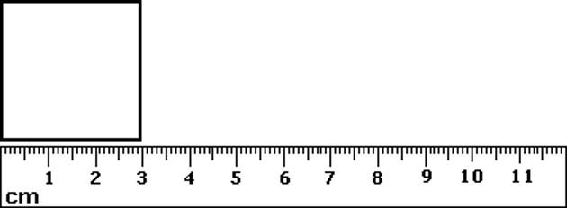

- Measure the mystery liquid. Report all parts of the measurement. ___43.0 ± .5 mL
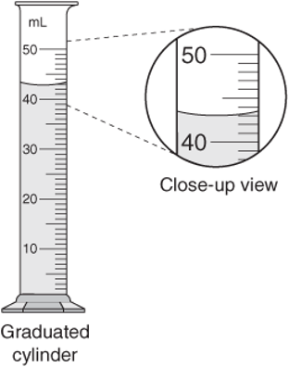

- Draw a measuring device that would give 7.3 ± .5 cm as a measurement.
- Why do we need a standardized system of measurement?
An international “language” of measurement allows scientists to share, interpret, and compare experimental findings with other scientists, regardless of nationality or language barriers.
- Complete the table with the SI units and symbols.
Physical Quantity | SI Unit | Symbol
length | meter | m
mass | kilogram | kg
volume | Liter, meter cubed | L, m³
temperature | Kelvin | K
time | second | s

