Momentum and Impulse Activity Name_________________ Per ____

The following activity is designed to address the Nebraska State Standard:

SC.HS.1.1.C Apply science and engineering ideas to design, evaluate, and refine a device that minimizes the force on a macroscopic object during a collision. Assessment is limited to qualitative evaluations and/or algebraic manipulations.

Directions: Using the materials provided, design and build a device that minimizes the force on a raw egg to prevent it from breaking during a collision. The length and width of the device are restricted to size of the carton.

DAY 1:
Phase 1--30 minutes--Get together with your lab triad and design a device that will minimize the force on an egg within a carton. Build the device.

Phase 2--20 minutes--Test your device to see the maximum height it can be released from before the egg breaks. Begin at 50 cm and repeat moving back at 10 cm increments.
DAY 2:
Phase 3--40 minutes--Momentum & Impulse Discussion and Practice

DAY 3:
Phase 4--20 minutes--Refine your original design and build a new carton. Test the new carton to see if your results improve! Send your results to Mr. Smith and Mrs. Sjuts.

Materials
Egg
Milk cartons
Styrofoam
Bubble wrap
Cotton balls
Plastic bags
Ramps
Carts
Paper bags
Rulers

Picture of Scenario

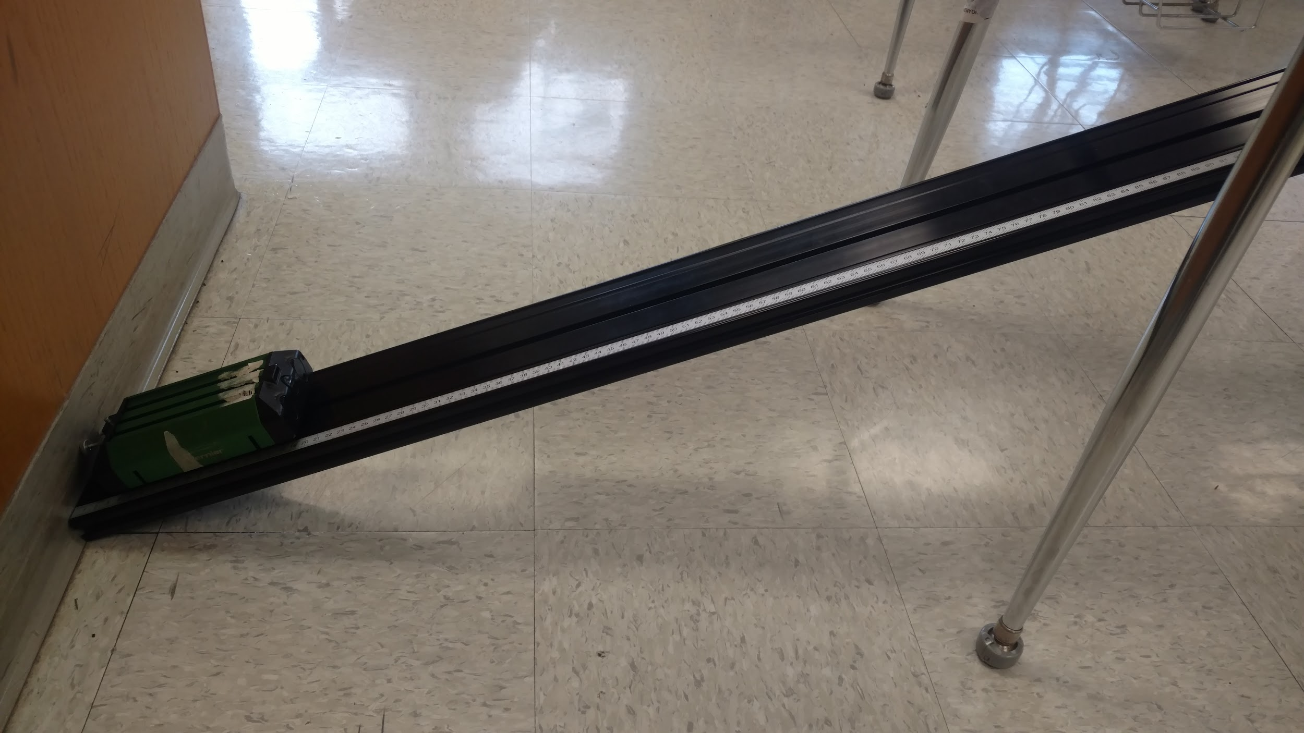

Draw a sketch of your final design and justify why you designed it the way you did!

Reflection Questions:

1. What worked well with your original design?

2. What worked poorly with your original design?

3. What was the major improvement you made?

