Momentum and Impulse Activity Name_________________ Per ____

The following activity is designed to address the Nebraska State Standard:

SC.HS.1.1.C Apply science and engineering ideas to design, evaluate, and refine a device that minimizes the force on a macroscopic object during a collision. Assessment is limited to qualitative evaluations and/or algebraic manipulations.

Directions: Using the materials provided, design and build a device that minimizes the force on a raw egg to prevent it from breaking during a collision. The length and width of the device are restricted to the size of the carton. To clarify, ALL materials must be INSIDE the milk carton. Please mark your milk carton so you’ll be able to easily identify it. *Be respectful with the materials by only taking what you will likely use, returning any extra materials to the cart, and cleaning up your area before the bell rings.

Phase 1--30 minutes--Get together with your lab group and design and build a device that will minimize the force on an egg within a carton. Build the device.

Phase 2--20 minutes--Test your device to see the maximum height it can be released from before the egg breaks. Begin at 50 cm and repeat moving back at 10 cm increments.

Materials (subject to change)
Egg
Milk cartons
Bubble wrap
Cotton balls
Tape
Plastic bags
Ramps
Carts

Picture of Scenario

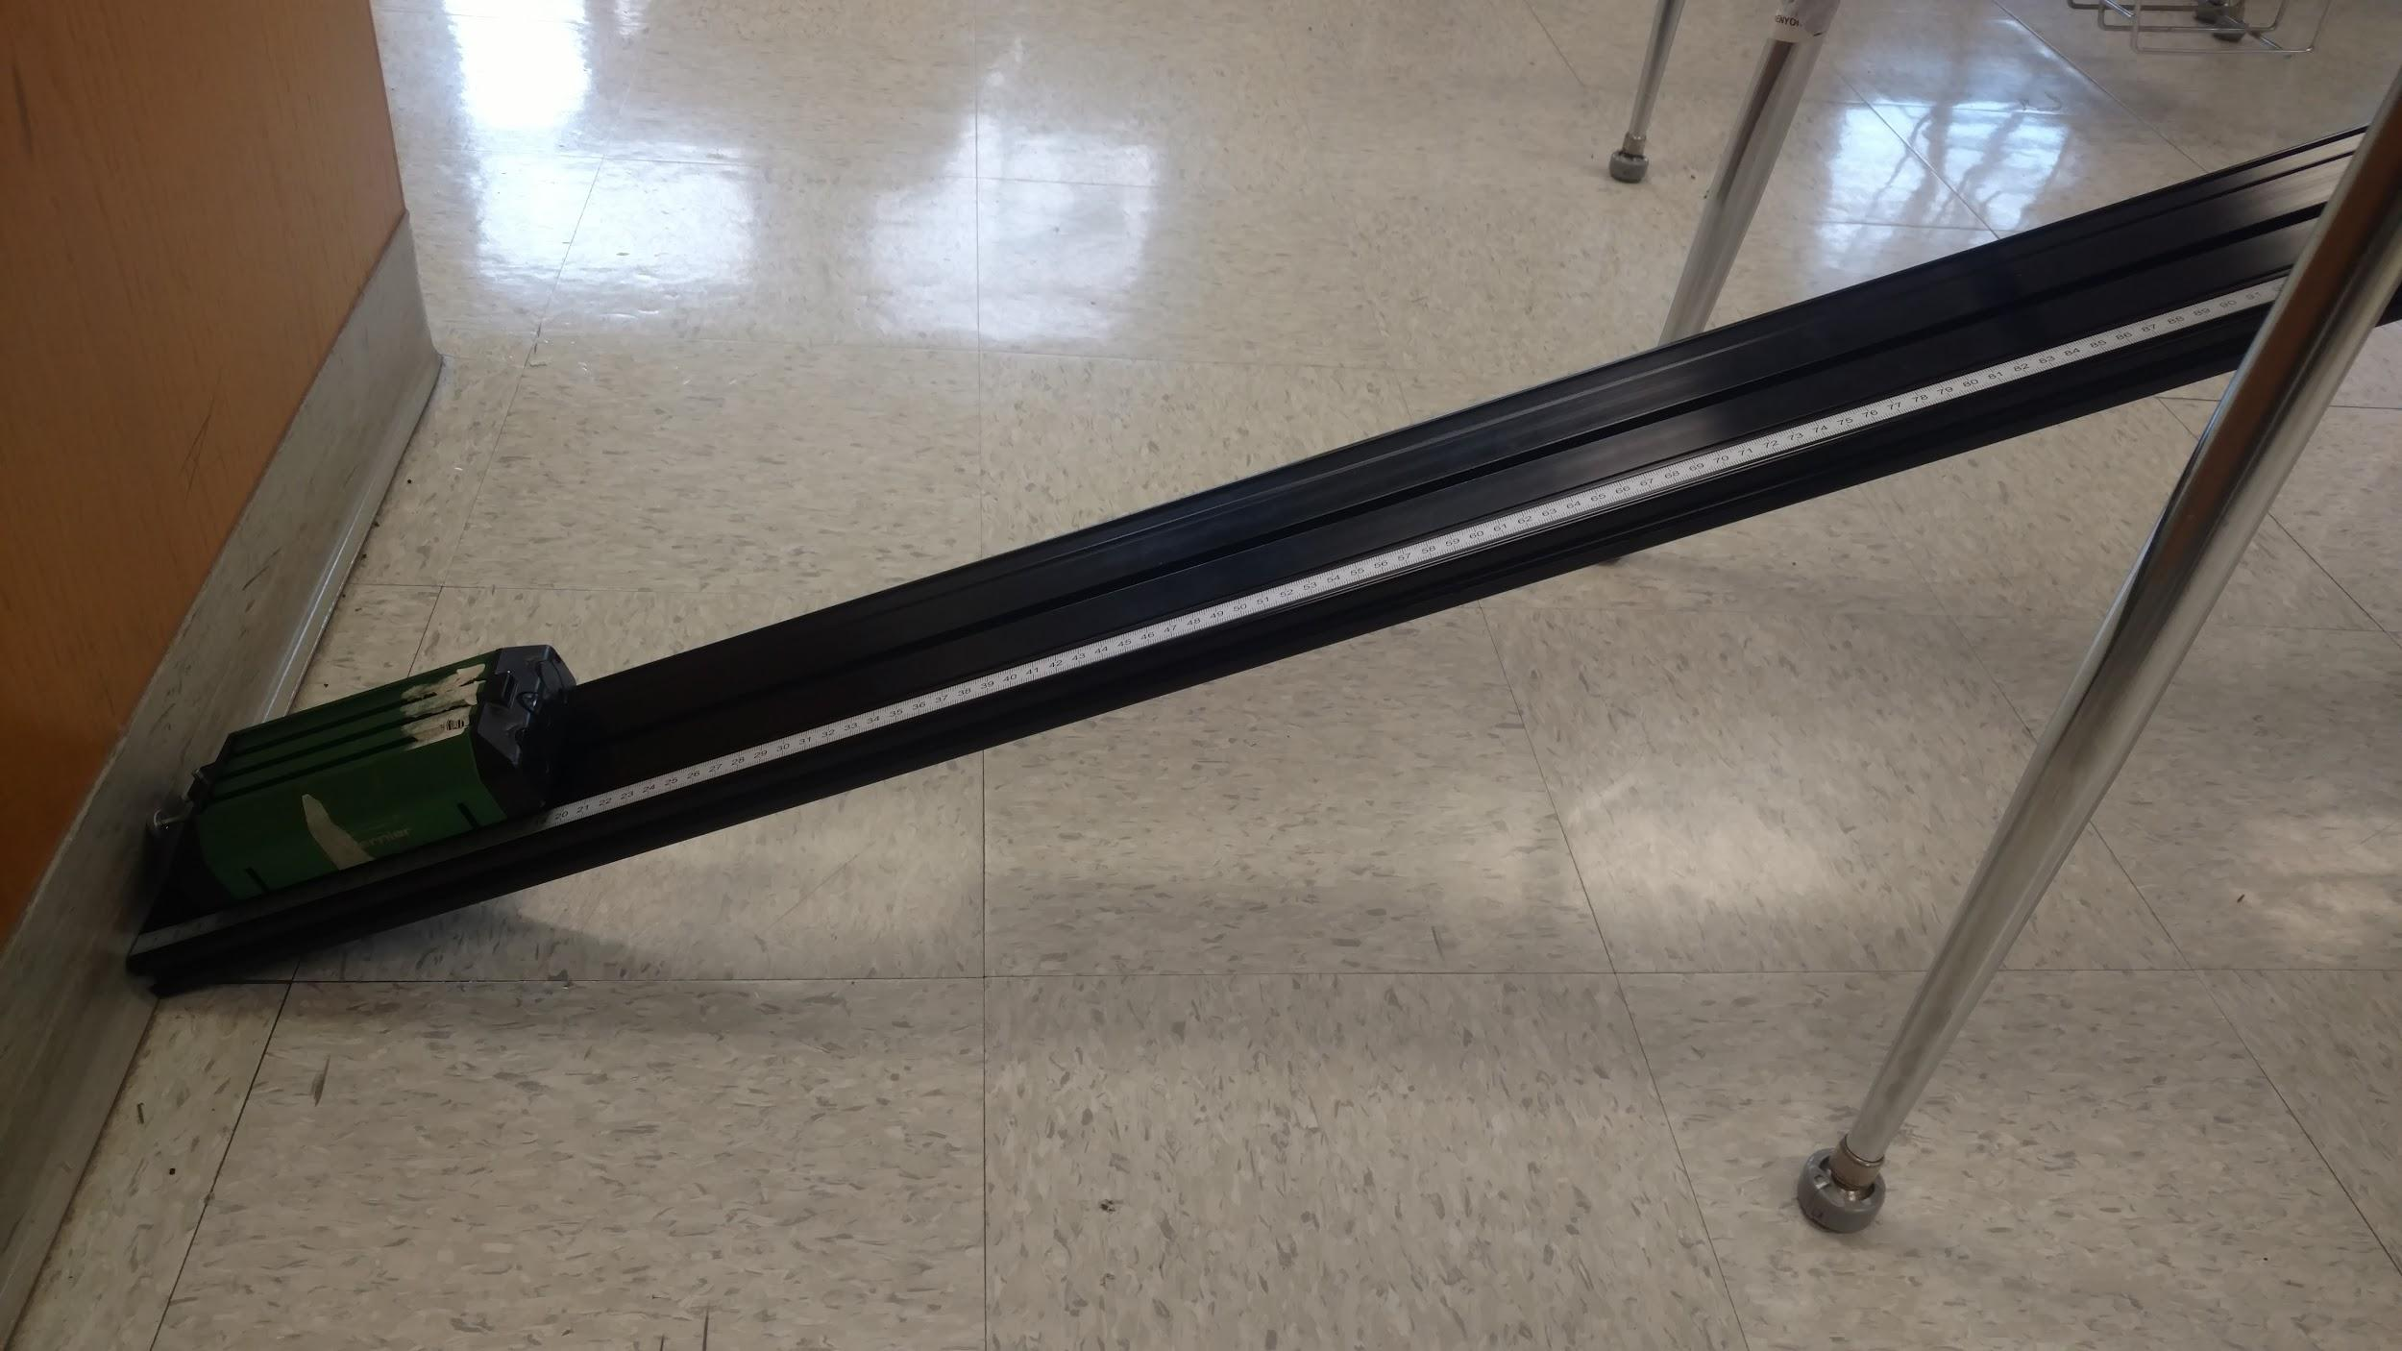

Draw a sketch of your final design and justify why you designed it the way you did!

Reflection Questions:

1. What worked well with your design?

2. What worked poorly with your design?

