Sugar Density Column Lab Name ______________________________

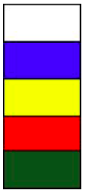
TASK: Create a density column using 4 different colored layers.

MATERIALS:
- 4 – 100 mL beakers
- test tube
- test tube rack
- sugar
- warm tap water
- food coloring
- 1 stirrer/stick
- 1 pipette/dropper
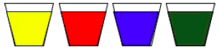
DIRECTIONS:
- Use proper lab procedures.
- Avoid cross contamination of colors.
- Each beaker will need 60 mL of warm tap water.
- Add 2-3 drops of food coloring per beaker to create a different color in each beaker.
- Choose the order of the colors.
- Determine how much sugar to add to each color.
- Add sugar solutions slowly down the side of the test tube using the pipette/dropper.
- If time allows, you may do multiple trials.
- Record your data in the table below.

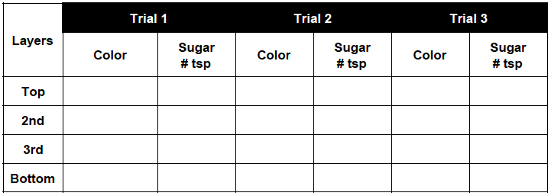
DATA:

OBSERVATIONS AND NOTES:

Trial 1 Trial 2 Trial 3

